Apologetics 101 lesson 6 Integrated Approach

How these approaches differ in some key elements
Scripture
- Classical – Conclusion. Rationally verified authority of God. God gave us our faculty of reason and directed his revelation to it.
- Evidentialist – Source. Factually verified story about Christ. Credible and reliable. Prophecies, Israel, Jesus
- Reformed – Foundation. Self-attesting authority of God.
- Fideism – Witness. Self-attesting story about Christ.

Religions
- Classical – Disproving other worldviews. There are finite number of worldviews. Shows non-Christian worldviews are logically self-contradictory.
- Evidentialist – Uniqueness of Christianity. Not all religions are same. Jesus were the only one raised from the dead.
- Reformed – Antithesis between Christian and non-Christian religion. Christianity alone presents an absolute and personal God.
- Fideism – Christianity not another religion, but a relationship

Existence of God
- Classical – Proving God’s existence. Ontological, cosmological, teleological, moral arguments.
- Evidentialist – Scientifically and historically presenting a case for God.
- Reformed – Belief in God as basic and foundational to all knowledge and proof.
- Fideism – Insulting trying to prove the existence of God, it’s a relational matter.

Evil in the world
- Classical – deductive. Proving the coexistence of God and evil in the world through metaphysical, moral and physical aspect
- Evidentialist – Inductive. How likely is it that God exists in light of how much evil there is?
- Reformed – Theological. How can God be the author of all and not be the author of sin?
- Fideism – Personal. How can I trust God despite evil?

Miracles
- Classical – Credentials of revelation. If God exists then miracles are possible. Miracles reveal the nature and purpose of the true God.
- Evidentialist – Evidence for God.
- Reformed – Prophetical. Revealed by God. Philosophy of facts vs facts alone.
- Fideism – Given by God in response to faith.

Jesus as God
- Classical – alternative
- Evidentialist – Evidence. Resurrection.
- Reformed – self-attesting Christ of scripture.
- Fideism – Get to know him and you will see.

Strength and weakness of each approach
Classical Approach
- Strength: 1) Affirm the universal applicability of reason; 2) Raises awareness of the role of worldviews; 3) recognizes common ground with non-Christians
- Weakness: 2) Overestimates the adequacy of reason; 2) Depends on arguments of debated validity and value; 3) Doesn’t address the personal dimensions of knowledge of belief

Evidentialist Approach
- Strength: 1) Recognizes probability cannot be avoided; 2) Uses methods of inquiry that are appealing to non-Christians; 3) Emphasizes the importance of factual evidence
- Weakness: 1) Doesn’t provide worldview context needed to access probability; 2) His hidden presuppositions; 3) Diminishes the role of personal factors

Reformed Approach
- Strength: 1) Establishes relationship between apologetics and theology; 2) raises epistemological awareness; 3) presents strong rational challenges to unbelief
- Weakness: 1) narrow form of Calvinism; 2) Underestimates facts; 3) Limits apologists to restrictive apologetic

Fideism Approach
- Strength: 1) Emphasizes the personal dimension of God; 2) humble view of human reasoning; 3) centers apologetics on Christ
- Weakness: 1) Undervalues Propositional knowledge; 2) over criticism of reason; 3) critical view of Bible

How do we integrate the 4 approaches?
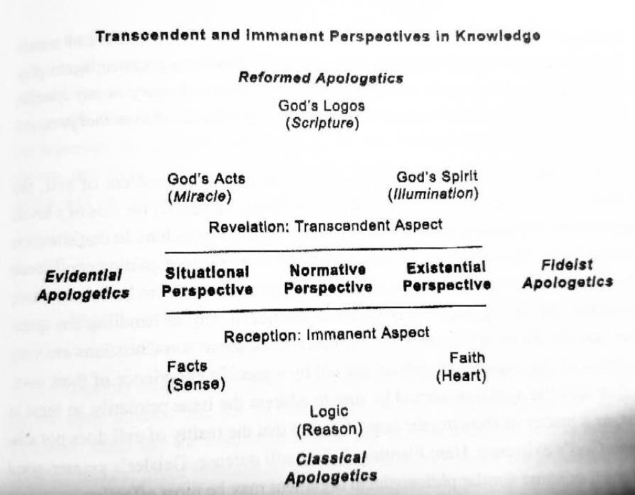
- One body, many gifts: The primary and regular way God gifts his people is not overtly supernatural. Instead, God’s main ministry gifts to the church are the use of natural abilities that Spirit-motivated and Spirit-enhanced. There are 2 different and basic kinds of apologists: evangelists and teachers.
- One world, many individuals: apologists should use common sense and try to match their apologetic to the person with whom they are speaking.
- One process, many stages: The validity of the apologetics doesn’t depend on its success, but on its utility in facilitating success through the hidden illuminating work of the Holy Spirit within non-Christians. It should provide basis for a non-Christian to move closer to embrace the Christian faith.
- One faith, many questions: different approaches are effective depending on the kinds of questions even on the same subject. For example, problem of evil.
- SPEAK THE TRUTH IN LOVE

Common Questions from Unbelievers | Possible Apologetic Arguments
It doesn’t matter to me if God exists or not. | If God exists, it matters. (F)
God may be real to you, but he’s not to me | Is Jesus real enough for you? (F)  You live everyday as if God exists. (R)
How do you know there is a God? | Without God, there is no meaning. (R)  No other worldview makes sense. (C)  There are many lines of evidence. (E)
The stories in the Bible are hard to believe. | If God exist, nothing is too hard for him. (C)
Why must we believe in the God of the Bible? | God fulfilled prophecy and did miracles. (E)
How do we know Jesus rose from the dead? | The tomb was empty and people saw Jesus. (E)
Wasn’t Jesus just a great prophet? | Great prophets don’t claim to be God. (C)
Why is Christianity alone the truth? | The God of Christianity is the only true God. (R)  Christ is the truth; Christianity points to him. (F)
I’d like to believe, but I’m not sure. | Read the Gospels and get to know Jesus. (F)
(C) Classical; (E) Evidential; (R) Reformed; (F) Fideism

